Software Requirements Specification:

Virtual Letter of Life Application

Version 3.0

Team Life Line (Fall 2020 Team 2)

Heather Barnes

Andrew Coleman

Panhavorn Hok

Michael Marcucci

Michael Shaw

Kimberly Van Allen

SWEN 670 Software Engineering Capstone

University of Maryland Global Campus

October 30, 2020

**REVISION HISTORY**

|  |  |  |
| --- | --- | --- |
| **Date** | **Version** | **Description** |
| 09/06/2020 | 1.0 | Initial SRS Document Release |
| 09/07/2020 | 1.1 | Version incorporates feedback from Roy Gordon. |
| 09/22/2020 | 1.2 | Version incorporates feedback from Dr. Assadullah. |
| 09/28/2020 | 2.0 | Version adds appendix of material from previous team’s SRS, per Dr. Assadullah. |
| 10/30/2020 | 3.0 | Version updates the status of current requirements to match the current project status, and adds new requirements that were identified during project implementation. |

**Table of Contents**

1. Introduction 6

1.1 Purpose 6

1.2 Intended Audience 6

1.3 Definitions, Acronyms, and Abbreviation 7

1.4 Overview 7

2. Scope 8

2.1 Scope Description 8

2.2 Out of Scope 8

3. Description 8

3.1 Use-Case Model Survey 8

3.2 User Classes and Permissions 9

4. Functional Requirements 10

4.1 Breakdown 10

4.1.1 Current Functional Requirements 10

4.1.2 Previously Completed Functional Requirements 15

4.1.3 Discarded Functional Requirements 19

4.2 Use Cases 20

4.3 Use Case Diagrams 27

5. Nonfunctional Requirements 30

5.1 Breakdown 30

5.1.1 Current Nonfunctional Requirements 30

5.1.2 Previously Completed Nonfunctional Requirements 34

5.1.3 Discarded Nonfunctional Requirements 37

APPENDIX A: Work from Previous Teams 38

I. Introduction 38

I. A. Project History 38

II. Salisbury, MD Letter of Life Form 39

III. Supplementary Requirements 40

IV. Graphical User Interface Design 40

IV. A. Virtual Letter of Life (Desktop) 40

IV. B. Virtual Letter of Life (Mobile) 46

**Table of Tables**

Table 1. Intended Audience 6

Table 2. Use Cases. 8

Table 3. User Classes and Permissions. 9

Table 4. Current Functional Requirements. 10

Table 5. Previously Completed Functional Requirements. 15

Table 6. Discarded Functional Requirements. 19

Table 7. Current Nonfunctional Requirements. 30

Table 8. Previously Completed Nonfunctional Requirements. 34

Table 9. Discarded Nonfunctional Requirements. 37

**Table of Figures**

Figure 1. EMT Use Case Diagram. 27

Figure 2. Participant Use Case Diagram. 28

Figure 3. System Administrator Use Case Diagram. 29

Figure 4. Salisbury, MD Letter of Life. 39

Figure 5. Mockup of VLOL Home Page. 40

Figure 6. Mockup of VLOL Registration Page. 41

Figure 7. Mockup of VLOL Login Page. 42

Figure 8. Mockup of VLOL About Page. 43

Figure 9. Mockup of VLOL Contact Page. 44

Figure 10. Mockup of VLOL Privacy Policy Page. 45

Figure 11. Mockup of VLOL Mobile Home Page. 46

Figure 12. Mockup of VLOL Mobile Registration Page. 47

Figure 13. Mockup of VLOL Mobile Login Page. 48

Figure 14. Mockup of VLOL Mobile About Page. 49

Figure 15. Mockup of VLOL Mobile Contact Page. 50

Figure 16. Mockup of VLOL Mobile Privacy Policy Page. 51

# Introduction

A Letter of Life, also known as a File of Life, is a paper form that provides to first responders a summary of important medical information regarding a person in need of medical attention. This information often includes the patient’s medical conditions, drugs or other medication, and allergies. Typically, a Letter of Life is kept in a visible location in the patient’s home where EMS personnel can find it quickly, such as on the patient’s refrigerator door.

A traditional Letter of Life, however, is only useful in emergencies occurring in or near the patient’s home, unless the patient opts to carry a copy of it with them. In the event of an emergency in which the patient’s Letter of Life is not immediately available, it becomes difficult for EMS personnel to obtain important medical information that could affect how emergency treatment is carried out. As a remedy to these situations, and as an enhancement to domestic emergencies, we propose the implementation of a web-based Letter of Life system, which we call Virtual Letter of Life. Virtual Letter of Life (VLOL) will serve as a digital replacement for paper Letters of Life, which will be accessible by EMS personnel by scanning a QR code kept in the patient’s home or on their person, as well as by searching the VLOL database.

## Purpose

This Software Requirements Specification (SRS) is intended to capture requirements for the Virtual Letter of Life system, which have been gathered in collaboration between the project team and external stakeholders.

## Intended Audience

This document is intended for an audience that includes the project team members and all project stakeholders. A list of specific members of this audience is presented below.

Table . Intended Audience

|  |  |
| --- | --- |
| **Project Team** | |
| Heather Barnes | Project Manager |
| Andrew Coleman | Developer, Documentation |
| Panhavorn Hok | Developer |
| Michael Marcucci | Tech Lead, Developer |
| Michael Shaw | Project Manager |
| Kimberly Van Allen | Testing Lead |
| **UMGC DevOps Team** | |
| Dustin Emerson | DevOps |
| Glenn Goodlett | DevOps |
| **External Stakeholders** | |
| Dr. Mir Assadullah | SWEN 670 Course Instructor |
| Jason Cantera | MIEMSS EMS Applications Coordinator |
| Robert Garcia | Previous VLOL Project Team Liaison |
| Roy Gordon | Project Management/Software Development Counsel |
| Avital Graves | Montgomery County, MD MIH Program Manager |
| Andrew Naumann | MIEMSS Director of Regional Programs |
| Captain Chris Truitt | Salisbury, MD EMS Captain |

## Definitions, Acronyms, and Abbreviation

A number of terms and acronyms appear in this document, which are defined below.

* **2FA:** 2 Factor Authentication
* **AC:** All Controls; a NIST control category.
* **AU:** Audit; a NIST control category.
* **CRISP:** Chesapeake Regional Information System for our Patients; a regional health information exchange serving Maryland and the District of Columbia.
* **CRUD:** Create, Read, Update and Delete.
* **eMEDS:** Maryland eMEDS Electronic Patient Care Reporting System.
* **EMR:** Electronic Medical Record.
* **EMS:** Emergency Medical Services.
* **EMT:** Emergency Medical Technician.
* **HTML:** Hypertext Markup Language; a markup language used in web page design.
* **IA:** Information Assurance; a NIST control category.
* **LOL:** Letter of Life
* **MIEMSS:** Maryland Institute for Emergency Medical Services Systems.
* **NIST SP:** National Institute of Standards and Technology Special Publication
* **Participant:** A person who has Letter of Life information stored in the VLOL system.
* **PII:** Personal Identifiable Information
* **QR Code:** Quick Response code; a matrix barcode scannable by smartphone cameras.
* **SC:** Systems and Communications; a NIST control category.
* **SI:** System & Information Integrity; a NIST control category.
* **SQL:** Structured Query Language; a family of languages for interacting with databases.
* **Sys Admin:** System administrator.
* **VLOL:** Virtual Letter of Life
* **W3C:** World Wide Web Consortium; the main international standards organization for the World Wide Web.

## Overview

This document is split into five sections and an appendix. A description of each section is provided below.

**Section 1. Introduction:** This section introduces the problem, this project aims to solve, the overall purpose of the project, the intended audience for this document, and lists some key terms and acronyms used in this document.

**Section 2. Scope:** This section defines the scope of the project and identifies specific items that are out-of-scope.

**Section 3. Description:** This section describes the project’s use cases, user classes, and user permissions.

**Section 4. Functional Requirements:** This section discusses the project’s functional requirements and use cases.

**Section 5. Nonfunctional Requirements:** This section discusses the project’s nonfunctional requirements.

**APPENDIX A: Work from Previous Teams:** This appendix presents material from the previous VLOL team’s SRS that was not duplicated or updated elsewhere in this document.

# Scope

The goal of this project is to develop a web-based software that will allow emergency medical responders to retrieve medical information, such as allergies, medication and medical conditions, which is contained in a Participant’s Letter of Life, from any location using a web interface.

## Scope Description

* Enable EMS personnel to gain access to a Participant’s Letter of Life information via a secure web interface, using laptops or mobile devices.
* Allow EMS personnel to scan a QR code to retrieve Letter of Life information belonging to an unresponsive or otherwise incapacitated Participant.
* Allow Participants and authorized users to create, update, read, and delete their medical records via a secure interface.
* Integrate the VLOL system with CRISP, MIEMSS, and eMEDS, for the purpose of automatically updating Participants’ Letter of Life information.

## Out of Scope

* Hands-on training for end users and medical providers.

# Description

The basic functionality of the VLOL system is to provide EMS secure web access to Participants’ LOL information from a laptop or mobile device, either by scanning a QR code or by performing a search. Participants and authorized users will also be able to create, read, update, and delete their LOL information via a secure web interface.

## Use-Case Model Survey

The table below lists the use cases making up the basic requirements of the VLOL system. Section 4 of this document describes each use case in greater depth.

Table . Use Cases.

| **ID** | **Use Case** | **Description** |
| --- | --- | --- |
| 1 | Admin Edit | Edits an existing account. |
| 2 | Admin Delete | Removes a user from the system. |
| 3 | Admin View | Displays user information. |
| 4 | Admin Listing | Lists existing users of the system. |
| 5 | User Listing | Lists existing Participants. |
| 6 | Search | Enables EMT personnel to search for a Participant’s LOL information. |
| 7 | Scan | Allows EMT to scan a QR code and retrieve the corresponding Participant’s LOL information. |
| 8 | User Add | Adds a Participant to the system. |
| 9 | User Edit | Edits existing Participant information. |
| 10 | User View | Displays Participant information. |
| 11 | User Delete | Removes Participant information from the system. |
| 12 | Log In | Allows users to log in to the system. |
| 13 | Log Out | Allows users to log out from the system. |
| 14 | Contact | Allows users to contact site administration via a secure form. |
| 15 | Home | Displays the VLOL landing page. |

## User Classes and Permissions

The VLOL system implements four user classes:

* **System Administrator (Admin):** Has full access to the VLOL system and its database; may view, modify, and remove any user accounts.
* **Patient Agent:** May access and update Participants’ Letter of Life information on behalf of the Participant.
* **EMS Personnel:** May access Participants’ Letter of Life information via search or QR code scan.
* **Participant:** May access, create, and modify Letter of Life information for their account, or for any account that has given them access permission; and may delete their own account.
* **Unauthenticated/Unauthorized User:** Only has access to view public-facing VLOL system pages, such as the landing, login, and about pages.

Table . User Classes and Permissions.

|  |  |  |  |  |  |
| --- | --- | --- | --- | --- | --- |
| **Permission** | **System Admin** | **Patient Agent** | **EMS Personnel** | **Participant** | **Unauthenticated and Unauthorized User** |
| Create LOL |  |  |  | X |  |
| Update LOL |  | X |  | X |  |
| View LOL |  | X | X | X |  |
| Scan QR Code |  |  | X |  |  |
| Search Users |  |  | X |  |  |
| Delete User | X |  |  | X (self only) |  |
| Modify User | X |  |  |  |  |
| View Users | X |  |  |  |  |
| View public-facing pages | X | X | X | X | X |

# Functional Requirements

This section lists the functional requirements of the VLOL system, in user story format, followed by a description of the project use cases.

## Breakdown

Since the VLOL project in its current incarnation is a continuation of a previous team’s work, we have reevaluated the pending functional requirements inherited from them, categorizing them into three groups: current requirements, which include both inherited requirements and new requirements; requirements completed by the previous project team; and inherited requirements that have been discarded by the new project team.

### Current Functional Requirements

Table . Current Functional Requirements.

| **ID** | **User Stories** | **Acceptance Criteria** | **Current Status** |
| --- | --- | --- | --- |
| REQ-1.1 | As an unauthenticated and unauthorized user, I want access to a Contact page, so I can solicit information about the LOL program or contact the System Administrator about an issue. | * View a Contact page for information solicitation about the LOL. * Contact the System Administrator about an issue. | **Complete**; the contact page contains a form, fillable by a visitor, which forwards its contents to system administrators via email (SMTP). |
| REQ-1.2 | As a registered, authenticated, and authorized Patient Agent, I want to search for Participants on a laptop or mobile device via an online form, so I can view, edit, and print Participant information, as necessary. | * Search for Participant information. | **Complete**; Patient agents can view all Participant accounts to which they have been granted access. |
| REQ-1.3 | As a registered, authenticated, and authorized System Administrator, I want to view a system error log, so I can inform the development team of problems or issues with the application. | * View system error log. | **Complete**; activity and errors are logged to separate files. |
| REQ-1.4 | As a registered, authenticated, and authorized Participant, I want to delete my LOL information from the database via an online form, so I may stop participating in the program. | * Delete medical history. | **Complete**; Participants have the option to delete their account via a button in their user profile settings. |
| REQ-1.5 | As a registered, authenticated, and authorized Participant, I want to print a barcode or quick response (QR) code with a link to my LOL (which I may affix to a bracelet, card, or necklace), so medical personnel can quickly access my medical history in case of an emergency. | * Print QR code or barcode with a link to LOL account. | **Complete**; Participants can generate and print a QR code via the user menu. |
| REQ-1.6 | As a registered, authenticated, and authorized Program Participant, I want access to a secure Contact page, so I can contact my Patient Agent (if designated) and/or the System Administrator about an issue. | * Contact Patient Agent or System Administrator about LOL. | **Complete**; the contact page contains a form, fillable by a visitor, which forwards its contents to system administrators via email (SMTP). |
| REQ-1.7 | As a registered, authenticated, and authorized Medical Services Provider, I want access to a secure Contact page, so I can contact the System Administrator about an issue. | * Contact System Administrator about an issue. | **Complete**; the contact page contains a form, fillable by a visitor, which forwards its contents to system administrators via email (SMTP). |
| REQ-1.8 | As a registered, authenticated, and authorized Patient Agent, I want to print a barcode or quick response (QR) code with a link to my Participant's LOL (which I may affix to a bracelet, card, or necklace), so medical personnel can quickly access their medical history in case of an emergency. | * Print a QR code or barcode with a link to Participant’s LOL. | **Complete**; Patient Agents can generate and print QR codes belonging to accounts they are authorized to access. |
| REQ-1.9 | As a registered, authenticated, and authorized Patient Agent, I want access to a secure Contact page, so I can contact the System Administrator about an issue. | * View Contact page * Contact System Administrator about issue. | **Complete**; the contact page contains a form, fillable by a visitor, which forwards its contents to system administrators via email (SMTP). |
| REQ-1.10 | As a registered, authenticated, and authorized Participant, I want to automatically update my LOL based on my patient data stored in CRISP and MIEMSS databases. | * VLOL system automatically updates and populates LOL with data pulled from CRISP/MIEMSS/eMEDS. | Not started, pending API/database access information from CRISP/MIEMSS/eMEDS. |
| REQ-1.11 | As a registered, authenticated, and authorized Medical Services Provider, I want Participants’ Letter of Life information to be kept accurate and up-to-date based on their patient data stored in CRISP and MIEMSS databases. | * VLOL system automatically updates and populates LOL with data pulled from CRISP/MIEMMS/eMEDS. | Not started; pending API/database access information from CRISP/MIEMSS/eMEDS. |
| REQ-1.12 | As a registered, authenticated, and authorized Medical Services Provider, I want Letter of Life information belonging to deceased Participants to be excluded from searches. | * VLOL user accounts include a deceased flag. | **Complete**; user accounts now have a deceased flag, which is editable by Administrators and Patient Agents. |
| REQ-1.13 | As a system, I want publicly-facing forms to require a CAPTCHA challenge before submission, in order to mitigate spam and automated attacks. | * Publicly-facing forms, where reasonable, require completion of a CAPTCHA challenge before submitting data. | **Complete**; reCAPTCHA challenges have been implemented on all publicly-facing forms, except for the login form. The team decided inclusion of a CAPTCHA test for login is redundant, as the VLOL system already locks accounts upon repeated failed login attempts. |
| REQ-1.14 | As a registered, authenticated user, I want forms for adding data to my account to include clear, accessible instructions and explanations of fields. | * Participant data entry forms include clear instructions and explanations of each field. | **Complete**; Participant data entry forms include clear instructions, and explanations for each field are provided as textual notices and tooltips. |
| REQ-1.15 | As a registered, authenticated user, I want forms for adding data to my account to automatically populate fields with information pulled from governmental and medical authorities whenever possible, in order to make the process of adding data to my account easier and quicker. | * Participant data entry forms auto-complete and auto-populate with data pulled from governmental and medical authorities. | **Complete**; Participant data entry forms, when possible, will auto-complete and/or auto-populate with data obtained from Pubmed MeSH and other sources. |
| REQ-1.16 | As a system administrator, I want the option to restrict viewing of Participant accounts so that only registered medical providers, EMS personnel, and administrators can access other users’ medical data. | * System-wide toggle that prevents Participants from viewing each other’s medical data, even when added as authorized users. | **Complete**; implemented as qrCode.onlyByRegistered in the application.properties file. |
| REQ-1.17 | As a registered, authenticated user, I want to be able to attach documents to my account, such as a Medical Power of Attorney. | * Participants are able to upload documents to their VLOL accounts. | **Complete**; a new menu option has been added that allows users to upload arbitrary documents. |
| REQ-1.18 | As a registered, authenticated user, I want to be able to attach advance directive forms and information to my account, so that medical personnel can obtain them quickly. | * Participants are able to upload advance directive forms/documents to their VLOL accounts. | **Complete**; a new menu option has been added that allows users to upload advance directive forms and documents. (This is functionally similar to the document upload feature, but the team decided that advance directives are important enough that they should be kept separate from other documents.) |

### Previously Completed Functional Requirements

Table . Previously Completed Functional Requirements.

| **ID** | **User Stories** | **Acceptance Criteria** |
| --- | --- | --- |
| CR-1.1 | As an unauthenticated and unauthorized user, I want access to an informative Landing page, so I can learn about the Letter of Life (LOL) program. | * View a homepage that introduces the LOL program. |
| CR-1.2 | As an unauthenticated and unauthorized user, I want access to a secure Registration page, so I can enroll in the Letter of Life program. | * Enroll in the LOL program using a secure Registration page. |
| CR-1.3 | As a registered, authenticated, and authorized Program Participant, I want to access my LOL via a Login Page, so unauthenticated and unauthorized users cannot access my medical history. | * Login to LOL account via the Login Page by providing username and password. |
| CR-1.4 | As a registered, authenticated, and authorized Program Participant, I want to add my LOL information to the database via an online form, so medical personnel can have access to my medical history in case of an emergency. | * Add medical history into LOL database. |
| CR-1.5 | As a registered, authenticated, and authorized Program Participant, I want to view my LOL information via an online form, so I can validate my information or print my LOL. | * View and validate medical history. |
| CR-1.6 | As a registered, authenticated, and authorized Program Participant, I want to edit my LOL information via an online form, so I can ensure my medical history is up to date. | * Edit medical history. |
| CR-1.7 | As a registered, authenticated, and authorized Medical Services Provider, I want to access the LOL system via a Login Page, so unauthenticated and unauthorized users cannot access a Participant's medical history. | * Login to VLOL system via Login Page. |
| CR-1.8 | As a registered, authenticated, and authorized Medical Services Provider, I want to edit my profile information via an online form, so I can ensure my information is up to date. | * Edit provider profile information. |
| CR-1.9 | As a registered, authenticated, and authorized Medical Services Provider, I want to search for Participants on a laptop or mobile device via an online form, so I can retrieve their medical history and provide correct medical care. | * Search for Participants medical history. |
| CR-1.10 | As a registered, authenticated, and authorized Medical Services Provider, I want to search for a Participant by scanning a barcode or quick response (QR) code, using a mobile device or authorized accessory, so I can retrieve their medical history and provide correct medical care. | * Scan QR code and retrieve Participant medical history. |
| CR-1.11 | As a registered, authenticated, and authorized Medical Services Provider, I want to view a Participant's medical history on a laptop or mobile device via an online form, so I can provide correct medical care. | * View Participant’s medical history. |
| CR-1.12 | As a registered, authenticated, and authorized Patient Agent, I want to access the LOL system via a Login Page, so unauthenticated and unauthorized users cannot access the medical history of my Participants. | * Login to LOL via Login Page. |
| CR-1.13 | As a registered, authenticated, and authorized Patient Agent, I want to edit my profile information via an online form, so I can ensure my information is up to date. | * Edit profile information. |
| CR-1.14 | As a registered, authenticated, and authorized Patient Agent, I want to search for a Participant by scanning a barcode or quick response (QR) code, using a mobile device or authorized accessory, so I can view, edit, and print Participant information, as necessary. | * Scan QR code or barcode to search for Participant’s information. |
| CR-1.15 | As a registered, authenticated, and authorized Patient Agent, I want to view the LOL information of my Participants via an online form, so I can validate their information or print their LOL. | * View LOL information of Participants. |
| CR-1.16 | As a registered, authenticated, and authorized Patient Agent, I want to edit the LOL information of my Participants via an online form, so I can ensure their medical history is up to date. | * Edit LOL information of Participants. |
| CR-1.17 | As a registered, authenticated, and authorized System Administrator, I want to access the LOL system via a Login Page, so unauthenticated and unauthorized users cannot access Participant medical history or user account information. | * Login to LOL using username and password via the Login Page. |
| CR-1.18 | As a registered, authenticated, and authorized System Administrator, I want to search for user accounts on a laptop or mobile device via an online form, so I can add, view, edit, and delete user accounts, as necessary. | * Search for user accounts. |
| CR-1.19 | As a registered, authenticated, and authorized System Administrator, I want to add accounts for Medical Services Providers and Patient Agents, so I can limit non-Participant access to Participant information. | * Add accounts for EMS Providers and Patient Agents. |
| CR-1.20 | As a registered, authenticated, and authorized System Administrator, I want to view accounts for Medical Services Providers and Patient Agents, so I can validate their information. | * View EMS Providers and Patient Agents accounts. |
| CR-1.21 | As a registered, authenticated, and authorized System Administrator, I want to edit accounts for Medical Services Providers and Patient Agents, so I can ensure their information is up to date. | * Edit EMS Providers and Patient Agents accounts. |
| CR-1.22 | As a registered, authenticated, and authorized System Administrator, I want to delete accounts for Medical Services Providers and Patient Agents, so I can limit non-Participant access to Participant information. | * Delete EMS Providers and Patient Agents accounts. |
| CR-1.23 | As a registered, authenticated, and authorized System Administrator, I want to search for Participants on a laptop or mobile device via an online form, so I can add, view, edit, and delete Participant information, as necessary. | * Search for Participants information. |
| CR-1.24 | As a registered, authenticated, and authorized System Administrator, I want to add accounts for Participants, so I can enroll them in the program. | * Register Program Participants. |
| CR-1.25 | As a registered, authenticated, and authorized System Administrator, I want to view accounts for Participants, so I can validate their information. | * View Participants account information. |
| CR-1.26 | As a registered, authenticated, and authorized System Administrator, I want to edit accounts for Participants, so I can ensure their information is up to date. | * Edit Participants account information. |
| CR-1.27 | As a registered, authenticated, and authorized System Administrator, I want to delete accounts for Participants, so I can disenroll them from the program. | * Delete Participants account information. |
| CR-1.28 | As a registered, authenticated, and authorized System Administrator, I want to view a system activity log, so I can audit access and use of the system. | * View system activity log. |
| CR-1.29 | As a registered, authenticated, and authorized System Administrator, I want to have access to the user guide, so I provide users with instructions on how to use the system. | * Access the user guide. |

### Discarded Functional Requirements

Table . Discarded Functional Requirements.

| **ID** | **User Stories** | **Reason for Rejection** |
| --- | --- | --- |
| DR-1.1 | As a registered, authenticated, and authorized Medical Services Provider, I want to print a MIEMSS-approved Short Form, populated with my Participant's information, so I can provide non-system medical facilities and staff with my Participant's medical history. | * No longer aligns with stakeholder expectations; stakeholders are more interested in digital-only functionality because CRISP already has robust printing features. |

## Use Cases

The VLOL web interface is comprised of 15 use cases, which are described in detail below.

1. **Use Case Name:** **Admin Edit**

**Summary:** The Admin Edit feature allows the Sys Admin to modify an existing user profile.

**Requirement ID:** CR-1.21, CR-1.26

|  |  |
| --- | --- |
| **Actor** | System Administrator |
| **Trigger** | The sys admin triggers the Edit feature event. |
| **Precondition** | System administrator has a super user role access and a user has an existing profile. |
| **System Response** | System displays current user information and prompt admin to make change as needed. |
| **Post Condition** | Modified user information displayed. |
| **Alternative Path** | Cancel editing user information. |

1. **Use Case Name: Admin** **Delete**

**Summary:** The Admin Delete feature enables the sys admin to remove an existing user form the system.

**Requirement ID:** CR-1.22, CR-1.27

|  |  |
| --- | --- |
| **Actor** | System Administrator |
| **Trigger** | The system admin triggers the Admin Delete event. |
| **Precondition** | System administrator has a super user role access and a user have existing profile. |
| **System Response** | System displays existing user information and prompt admin to delete user. |
| **Post Condition** | User removed from the system. |
| **Alternative Path** | Cancel deletion. |

1. **Use Case Name: Admin View**

**Summary:** The Admin View feature allows the sys admin to view a specific user information.

**Requirement ID:** CR-1.18

|  |  |
| --- | --- |
| **Actor** | System Administrator |
| **Trigger** | The system admin triggers the Admin View event. |
| **Precondition** | System administrator has a super user role access and there are existing user profiles. |
| **System Response** | System displays existing user information. |
| **Post Condition** | User information displayed. |
| **Alternative Path** | None. |

1. **Use Case Name: Admin** **Listing**

**Summary:** The Admin Listing feature allows the sys admin to view lists of users that are in the virtual letter of life database.

**Requirement ID:** CR-1.22, and CR-1.25

|  |  |
| --- | --- |
| **Actor** | System Administrator |
| **Trigger** | The system admin triggers the Admin Listing event. |
| **Precondition** | System administrator has a super user role access. |
| **System Response** | System displays list of users. |
| **Post Condition** | List of existing users displayed. |
| **Alternative Path** | None. |

1. **Use Case Name: User Listing**

**Summary:** The User Listing feature allows EMT personnel to view lists of Participants’ that are in the virtual letter of life database.

**Requirement ID:** CR-1.20

|  |  |
| --- | --- |
| **Actor** | EMT personnel |
| **Trigger** | EMT personnel triggers the User Listing event. |
| **Precondition** | EMT personnel authenticated and Participants’ information is in the virtual life of letter database. |
| **System Response** | System allows user to view list of participants. |
| **Post Condition** | List of existing participants displayed. |
| **Alternative Path** | None. |

1. **Use Case Name**: **Search**

**Summary:** The Search feature provides the ability to search for a participant.

**Requirement ID:** CR-1.9, CR-1.18

|  |  |
| --- | --- |
| **Actor** | EMT personnel, system admins and Participants. |
| **Trigger** | User triggers Search event. |
| **Precondition** | User have the appropriate permission to search. |
| **System Response** | System prompt user to scan QR code. |
| **Post Condition** | User scan QR code. |
| **Alternative Path** | Cancel Search. |

1. **Use Case Name: Scan**

**Summary:** The Scan feature allows EMT personnel to scan barcode or QR code and search participant’s letter of life from the virtual letter of life database.

**Requirement ID:** CR-1.9, CR-1.10, and CR-1.14

|  |  |
| --- | --- |
| **Actor** | EMT personnel |
| **Trigger** | EMT personnel triggers the Scan event. |
| **Precondition** | EMT personnel authenticated and Participant information is in the virtual life of letter database. |
| **System Response** | System prompts user to scan barcode or QR code. |
| **Post Condition** | Participant letter of life displayed on the screen. |
| **Alternative Path** | Cancel search. |

1. **Use Case Name: User Register**

**Summary:** The User register as a participant user to create an account.

**Requirement ID:** CR-1.2

|  |  |
| --- | --- |
| **Actor** | Participant |
| **Trigger** | Participant triggers the User Add event. |
| **Precondition** | None. |
| **System Response** | System displays list of questions for the participant to complete and save. |
| **Post Condition** | Participant information is added into the database. |
| **Alternative Path** | Cancel and no account gets created. |

1. **Use Case Name: User** **Edit**

**Summary:** The User Edit feature allows participant to edit existing information.

**Requirement ID:** CR-1.6, CR-1.8, CR-1.16

|  |  |
| --- | --- |
| **Actor** | Participant |
| **Trigger** | Participant  triggers User Edit event. |
| **Precondition** | Participant have an existing account. |
| **System Response** | System displays existing information and prompt user to modify information as needed. |
| **Post Condition** | The modified information gets stored in the database. |
| **Alternative Path** | Cancel change and nothing gets modified. |

1. **Use Case Name: User** **View**

**Summary:** The User View feature allows Participant to view his/her account information.

**Requirement ID:** CR-1.5, CR-1.11, CR-1.15

|  |  |
| --- | --- |
| **Actor** | Participant |
| **Trigger** | Participant triggers User View event. |
| **Precondition** | Participant have an existing account. |
| **System Response** | System displays existing account information. |
| **Post Condition** | Participant account information gets displayed. |
| **Alternative Path** | None. |

1. **Use Case Name: User Delete**

**Summary:** The User Delete feature allows Participant to delete his/her account from the system.

**Requirement ID:** REQ-1.3

|  |  |
| --- | --- |
| **Actor** | Participant |
| **Trigger** | Participant triggers the User Delete event. |
| **Precondition** | Participant have an existing account. |
| **System Response** | System prompt Participant to confirm and proceed with deletion. |
| **Post Condition** | Account gets deleted from the system. |
| **Alternative Path** | Cancel deletion. |

1. **Use Case Name**: **Log In**

**Summary:** The Log In feature allows users (EMT personnel, system admins and Participants) to login into the system.

**Requirement ID:** CR-1.3, CR-1.7, CR-1.12, CR-1.17

|  |  |
| --- | --- |
| **Actor** | EMT personnel, system admins and Participants. |
| **Trigger** | User triggers Login option. |
| **Precondition** | User must be authenticated and have an existing account. |
| **System Response** | System prompts user to enter login information. |
| **Post Condition** | User is logged into virtual letter of life interface. |
| **Alternative Path** | Cancel login. |

1. **Use Case Name**: **Log Out**

**Summary:** The Logout feature allows user to log out of the system.

**Requirement ID:**

|  |  |
| --- | --- |
| **Actor** | EMT personnel, system admins and Participants. |
| **Trigger** | User triggers Logout event. |
| **Precondition** | User is logged into the system. |
| **System Response** | System logs out user from account. |
| **Post Condition** | User is logged out of virtual letter of life interface. |
| **Alternative Path** | None. |

1. **Use Case Name**: **Contact**

**Summary:** The Contact feature provides user with contact information.

**Requirement ID:** REQ-1.1, REQ-1.5, and REQ-1.6

|  |  |
| --- | --- |
| **Actor** | EMT personnel, system admins and Participants. |
| **Trigger** | User triggers Contact event. |
| **Precondition** | User is on virtual letter of life website. |
| **System Response** | System displays contact information. |
| **Post Condition** | Use views contact information page. |
| **Alternative Path** | None. |

1. **Use Case Name**: **Home**

**Summary:** The Home page displays the landing page of VLOL.

**Requirement ID:** CR-1.1

|  |  |
| --- | --- |
| **Actor** | EMT personnel, system admins and Participants. |
| **Trigger** | User triggers Home event. |
| **Precondition** | User is on virtual letter of life website. |
| **System Response** | System displays the landing page of the site. |
| **Post Condition** | Use views the home page of VLOL. |
| **Alternative Path** | None. |

## Use Case Diagrams

The following diagrams illustrate the relationships among the use cases described in section 4.2, on an actor-by-actor basis.

Figure . EMT Use Case Diagram.

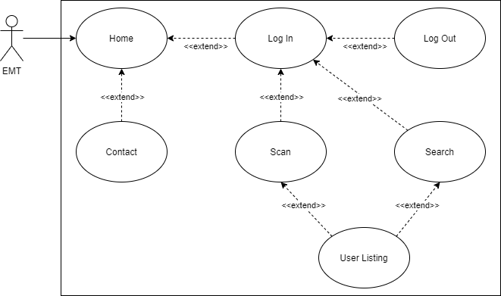

Figure . Participant Use Case Diagram.

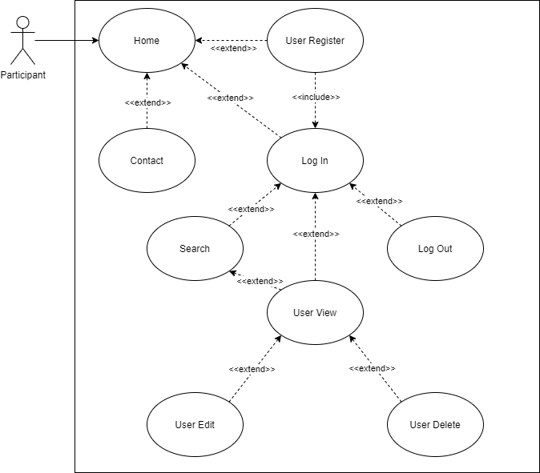

Figure . System Administrator Use Case Diagram.

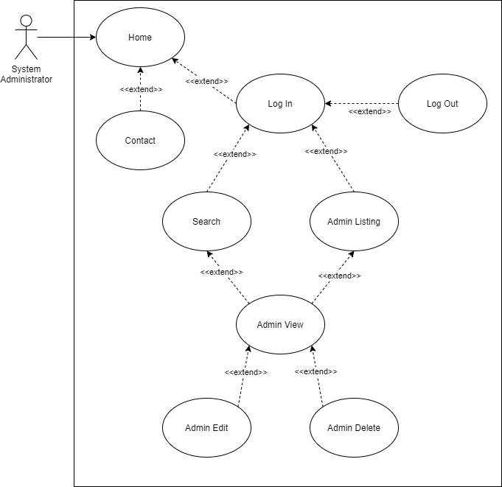

# Nonfunctional Requirements

## Breakdown

Since the VLOL project in its current incarnation is a continuation of a previous team’s work, we have reevaluated the pending nonfunctional requirements inherited from them, categorizing them into three groups: pending requirements, which include both inherited requirements and any new requirements; requirements completed by the previous project team; and inherited requirements that have been discarded by the new project team.

### Current Nonfunctional Requirements

Table . Current Nonfunctional Requirements.

| **ID** | **User Stories** | **Acceptance Criteria** | **Current Status** |
| --- | --- | --- | --- |
| NF-1.1 | As a system, I want to limit Create-Read-Update-Delete (CRUD) access to authenticated and authorized users only, so I may preserve the confidentiality and integrity of Personally Identifiable Information (PII) | * Functionality and page access are controlled based on user role. | **Complete**; Participants are unable to access each other’s accounts without authorization. |
| NF-1.2 | As a system, I want the following NIST SP 800-53 controls enforced throughout the application, so I may preserve the confidentiality and integrity of PII, as well as the availability of the system:   1. AC-2: ACCOUNT MANAGEMENT 2. AC-3: ACCESS ENFORCEMENT 3. AC-7: UNSUCCESSFUL LOGON ATTEMPTS 4. AC-8: SYSTEM USE NOTIFICATION 5. AC-11: SESSION LOCK 6. AC-12: SESSION TERMINATION 7. AU-2: AUDIT EVENTS 8. AU-8: TIME STAMPS 9. IA-2: IDENTIFICATION AND AUTHENTICATION (ORGANIZATIONAL USERS) 10. SC-13: CRYPTOGRAPHIC PROTECTION 11. SC-23: SESSION AUTHENTICITY 12. SI-10: INFORMATION INPUT VALIDATION 13. SI-11: ERROR HANDLING | * All specified NIST SP 800-53 controls are fully implemented. | * AC-2, AC-3, AC-7, AC-8, AC-11, AC-12, AU-2, AU-8, IA-2, SC-13, SC-23, and SI-10 are implemented. * SI-11 is partially implemented. |
| NF-1.2.b | As a system, I want the following NIST SP 800-53 controls enforced throughout the application, so I may preserve the confidentiality and integrity of PII, as well as the availability of the system:  AC-3: ACCESS ENFORCEMENT | * The VLOL system adheres to AC-3 guidance, as defined in NIST Special Publication 800-53 (Rev. 4). * Link to AC-3 definition: <https://nvd.nist.gov/800-53/Rev4/control/AC-3> | **Complete**; Participants are unable to access each other’s accounts without authorization. |
| NF-1.2.c | As a system, I want the following NIST SP 800-53 controls enforced throughout the application, so I may preserve the confidentiality and integrity of PII, as well as the availability of the system:  AC-7: UNSUCCESSFUL LOGON ATTEMPTS | * The VLOL system adheres to AC-7 guidance, as defined in NIST Special Publication 800-53 (Rev. 4). * Link to AC-7 definition: https://nvd.nist.gov/800-53/Rev4/control/AC-7 | **Complete**; repeated failed login attempts result in the user’s account being locked automatically and an email about how to resolve the issue is dispatched to the user’s registered email address. The number of failed attempts before this feature is triggered is configurable by system administrators. |
| NF-1.2.g | As a system, I want the following NIST SP 800-53 controls enforced throughout the application, so I may preserve the confidentiality and integrity of PII, as well as the availability of the system:  AU-2: AUDIT EVENTS | * The VLOL system adheres to AU-2 guidance, as defined in NIST Special Publication 800-53 (Rev. 4). * Link to AU-2 definition: <https://nvd.nist.gov/800-53/Rev4/control/AU-2> | **Complete**; server activity and errors are logged to separate files. |
| NF-1.2.m | As a system, I want the following NIST SP 800-53 controls enforced throughout the application, so I may preserve the confidentiality and integrity of PII, as well as the availability of the system:  SI-11: ERROR HANDLING | * The VLOL system adheres to SI-11 guidance, as defined in NIST Special Publication 800-53 (Rev. 4). * Link to SI-11 definition: <https://nvd.nist.gov/800-53/Rev4/control/SI-11> | Currently, errors are collected, and users are redirected to a custom error page (the stack trace of the error is displayed if the user is an administrator). System activity and errors are logged to separate files.   However, errors are not forwarded to a system administrator account via a Simple Mail Transfer Protocol (SMTP) service. |
| NF-1.3 | As a system, I want to unit test all functions and methods, so I can ensure boundary conditions are not violated. | * Unit testing is implemented for all functions and methods. | The team has prioritized creating unit tests for all model methods and their edge conditions, to prevent SQL injections or storage of bad data. However, all methods in the configuration, controller, repository, and service folders need unit tests. |
| NF-1.4 | As a system, I want to style and comment all code per the appropriate style guide, so I can properly maintain and turn-over the application, as necessary. | * All code adheres to the Google Style Guide. * All code is commented according to recommendations in the Google Style Guide. * All classes and methods have JavaDoc comments. * JavaDocs are generated for all classes. | Class header comments per the Google Style Guide are mostly complete, but most methods do not have JavaDoc comments and JavaDocs have not been generated. |
| NF-1.5 | As a system, I want all CRITICAL, HIGH, MEDIUM, and STANDARD issues and risks identified during static and dynamic analysis, corrected before uploading to a repository, so I can ensure the repository's code meets the bug bar. | * All identified issues, bugs, and vulnerabilities are corrected prior to code being accepted into production builds. | SonarQube reports 29 potential vulnerabilities. |
| NF-1.6 | As a system, I want new registrants to verify their accounts via a link sent via email (2FA), so I may mitigate the creation of fake accounts. | * Two-factor authentication (2FA) via email is implemented. * The account-creation process includes 2FA. | **Complete**; account creation now requires email verification. |
| NF-1.7 | As a system, I want user sessions to timeout within 30 minutes, so I may prevent inadvertent disclosure of PII. | * User sessions are automatically logged out after 30 minutes of inactivity. | **Complete**; user sessions are automatically logged out following 30 minutes of inactivity. |
| NF-1.9 | As a system, I want all presentation code to be HTML5 and W3C compliant, so I can ensure the application provides the same functionality across different platforms. | * All HTML, CSS, and JavaScript code adheres to HTML5 and W3C standards. * All Java code that generates HTML, CSS, or JavaScript code produces output that adheres to HTML5 and W3C standards. * All presentation code is designed to adjust to device or browser display dimensions in an elegant and functional manner. | Not started. |
| NF-1.10 | As a user, I want the VLOL user interface to maintain accessibility as defined by Section 508 of the Rehabilitation Act. | * User interface conforms to Section 508 standards. | **Complete**; the user interface has been audited based on 508 standards and has been modified to include more accessibility features, such as management of keyboard focus order of on-screen elements and warnings about auto-completing fields. |

### Previously Completed Nonfunctional Requirements

Table . Previously Completed Nonfunctional Requirements.

| **ID** | **User Stories** | **Acceptance Criteria** |
| --- | --- | --- |
| CNF-1.1 | As a system, I want all user input validated, so I may prevent injection and scripting attacks. | * All user input is sanitized and validated before further processing. |
| CNF-1.1.a | As a system, I want the following NIST SP 800-53 controls enforced throughout the application, so I may preserve the confidentiality and integrity of PII, as well as the availability of the system:  AC-2: ACCOUNT MANAGEMENT | * The VLOL system adheres to AC-2 guidance, as defined in NIST Special Publication 800-53 (Rev. 4). * Link to AC-2 definition: <https://nvd.nist.gov/800-53/Rev4/control/AC-2> |
| CNF-1.1.d | As a system, I want the following NIST SP 800-53 controls enforced throughout the application, so I may preserve the confidentiality and integrity of PII, as well as the availability of the system:  AC-8: SYSTEM USE NOTIFICATION | * The VLOL system adheres to AC-8 guidance, as defined in NIST Special Publication 800-53 (Rev. 4). * Link to AC-8 definition: <https://nvd.nist.gov/800-53/Rev4/control/AC-8> |
| CNF-1.1.e | As a system, I want the following NIST SP 800-53 controls enforced throughout the application, so I may preserve the confidentiality and integrity of PII, as well as the availability of the system:  AC-11: SESSION LOCK | * The VLOL system adheres to AC-11 guidance, as defined in NIST Special Publication 800-53 (Rev. 4). * Link to AC-11 definition: <https://nvd.nist.gov/800-53/Rev4/control/AC-11> |
| CNF-1.1.f | As a system, I want the following NIST SP 800-53 controls enforced throughout the application, so I may preserve the confidentiality and integrity of PII, as well as the availability of the system:  AC-12: SESSION TERMINATION | * The VLOL system adheres to AC-12 guidance, as defined in NIST Special Publication 800-53 (Rev. 4). * Link to AC-12 definition: <https://nvd.nist.gov/800-53/Rev4/control/AC-12> |
| CNF-1.1.h | As a system, I want the following NIST SP 800-53 controls enforced throughout the application, so I may preserve the confidentiality and integrity of PII, as well as the availability of the system:  AU-8: TIME STAMPS | * The VLOL system adheres to AU-8 guidance, as defined in NIST Special Publication 800-53 (Rev. 4). * Link to AU-8 definition: <https://nvd.nist.gov/800-53/Rev4/control/AU-8> |
| CNF-1.1.i | As a system, I want the following NIST SP 800-53 controls enforced throughout the application, so I may preserve the confidentiality and integrity of PII, as well as the availability of the system:  IA-2: IDENTIFICATION AND AUTHENTICATION (ORGANIZATIONAL USERS) | * The VLOL system adheres to IA-2 guidance, as defined in NIST Special Publication 800-53 (Rev. 4). * Link to IA-2 definition: <https://nvd.nist.gov/800-53/Rev4/control/IA-2> |
| CNF-1.1.j | As a system, I want the following NIST SP 800-53 controls enforced throughout the application, so I may preserve the confidentiality and integrity of PII, as well as the availability of the system:  SC-13: CRYPTOGRAPHIC PROTECTION | * The VLOL system adheres to SC-13 guidance, as defined in NIST Special Publication 800-53 (Rev. 4). * Link to SC-13 definition: <https://nvd.nist.gov/800-53/Rev4/control/SC-13> |
| CNF-1.1.k | As a system, I want the following NIST SP 800-53 controls enforced throughout the application, so I may preserve the confidentiality and integrity of PII, as well as the availability of the system:  SC-23: SESSION AUTHENTICITY | * The VLOL system adheres to SC-23 guidance, as defined in NIST Special Publication 800-53 (Rev. 4). * Link to SC-23 definition: <https://nvd.nist.gov/800-53/Rev4/control/SC-23> |
| CNF-1.1.l | As a system, I want the following NIST SP 800-53 controls enforced throughout the application, so I may preserve the confidentiality and integrity of PII, as well as the availability of the system:  SI-10: INFORMATION INPUT VALIDATION | * The VLOL system adheres to SI-10 guidance, as defined in NIST Special Publication 800-53 (Rev. 4). * Link to SI-10 definition: <https://nvd.nist.gov/800-53/Rev4/control/SI-10> |
| CNF-1.2 | As a system, I want all SQL queries to use prepared statements, so I can prevent SQL injection attacks. | * All SQL queries use parameterized templates. |
| CNF-1.3 | As a system, I want all tables to be normalized to 3rd Normal Form, so I can improve data integrity and reduce data redundancy. | * All database tables are correctly normalized to 3rd normal form. |
| CNF-1.4 | As a system, I want to incorporate static code analysis, using both automated and manual methods, so I can ensure there are no weaknesses due to code syntax. | * Whitebox testing is implemented through unit testing and SonarQube integration. |
| CNF-1.5 | As a system, I want to incorporate dynamic code analysis and penetration testing, so I can ensure there are no vulnerabilities due to code semantics. | * Dynamic code analysis is implemented in the project build system. |
| CNF-1.6 | As a system, I want to incorporate version control, so I may audit and track code generation. | * Project changes are tracked via git and propagated via Github. |
| CNF-1.7 | As a system, if a CRITICAL, HIGH, MEDIUM, and STANDARD issue and risk cannot be corrected immediately, I want it recorded in a bug log, so I can ensure the issue or risk is corrected before deployment. | * Errors and other issues are logged in a human-readable format. |

### Discarded Nonfunctional Requirements

Table 9. Discarded Nonfunctional Requirements.

| **ID** | **User Stories** | **Reason for Rejection** |
| --- | --- | --- |
| DNF-1.1 | As a system, I want all non-verified accounts to be deleted within 24 hours, so I may prevent database bloating. | * 24 hours is sufficient time for DDOS attacks to bloat the database; implementing a CAPTCHA check for user registration is a better solution. |
| DNF-1.2 | As a system, I want to limit multi-account access to authorized devices only (MAC Whitelisting), so I may preserve the confidentiality and integrity of PII, as well as the availability of the system. | * MAC whitelisting would hinder user-friendliness and pose issues for EMS professionals who share devices. * MAC whitelisting could make it prohibitively difficult for homeless people to use VLOL, which is a use case stakeholders are specifically interested in supporting. |

APPENDIX A: Work from Previous Teams

I. Introduction

I. A. Project History

The Virtual Letter of Life system began in May of 2020 as a class project designed and developed by a team of students (the Summer 2020 team) attending the graduate-level Software Engineering capstone course at the University of Maryland Global Campus. Following the conclusion of the Summer 2020 semester, the Summer 2020 team turned over control of the project and all project materials to a new team of students, the Fall 2020 team.

For the sake of maintaining a historical record of the Summer 2020 team’s work, this appendix contains any material from the Summer 2020 SRS that has not been duplicated or adapted elsewhere in this document. This material is presented as-is, with minimal edits aside from modifications to fit the content to this document’s format or to provide context. Additionally, all material in this document that was lifted directly from previous teams’ documentation is presented in a grey typeface.

The VLOL Summer 2020 Team consists of seven members:

* Mohammed Allibalogun
* Charles Baisie
* Jamal Bourne
* Meron Getachew Debela
* Robert Garcia
* Augustin Mwamba
* Sefanit Urgessa

II. Salisbury, MD Letter of Life Form

*The following form, obtained from the Salisbury, MD Fire Department, was the basis for the initial user data models used in the VLOL project.*

Figure 4. Salisbury, MD Letter of Life.

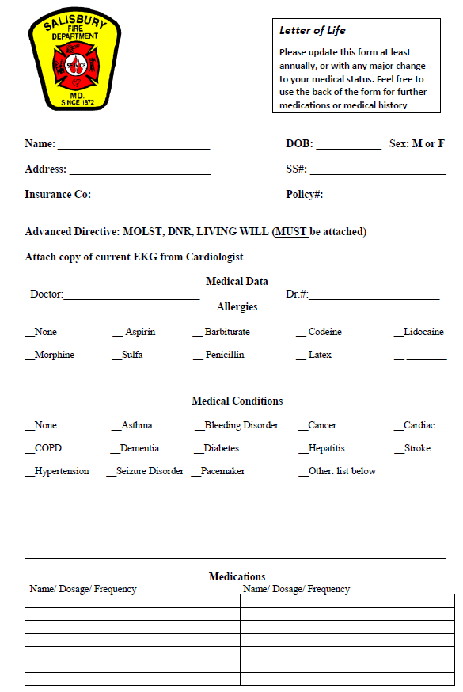

III. Supplementary Requirements

*The following list of technical specifications is out-of-date and is included only for historical purposes.*

* Software Specifications (from IT directory City of Salisbury):
  + Operating System: Linux (Heroku-18 / Ubuntu 18.04)
  + Web Server: Tomcat Embedded Jasper (10.0.0-M6)
  + Database Server: H2 (Development) / MySQL (Development / Production)
  + Database Language: SQL
  + Languages and Framework: Java (Spring Boot) / HTML / CSS / JavaScript
  + Repository: GitHub/UMGC Git Repositories
  + Development Hosting: Heroku (https://warm-hamlet-22515.herokuapp.com/) using 2048-bit SSL/TLS
  + Production Hosting: Heroku / TBD

IV. Graphical User Interface Design

IV. A. Virtual Letter of Life (Desktop)

*The following user interface mockups formed the basis of VLOL’s initial user interface design.*

**1. Home**

Screen Name: VLOL (Virtual Letter of Life) Home Page

Requirement ID: REQ-1.1

Figure 5. Mockup of VLOL Home Page.

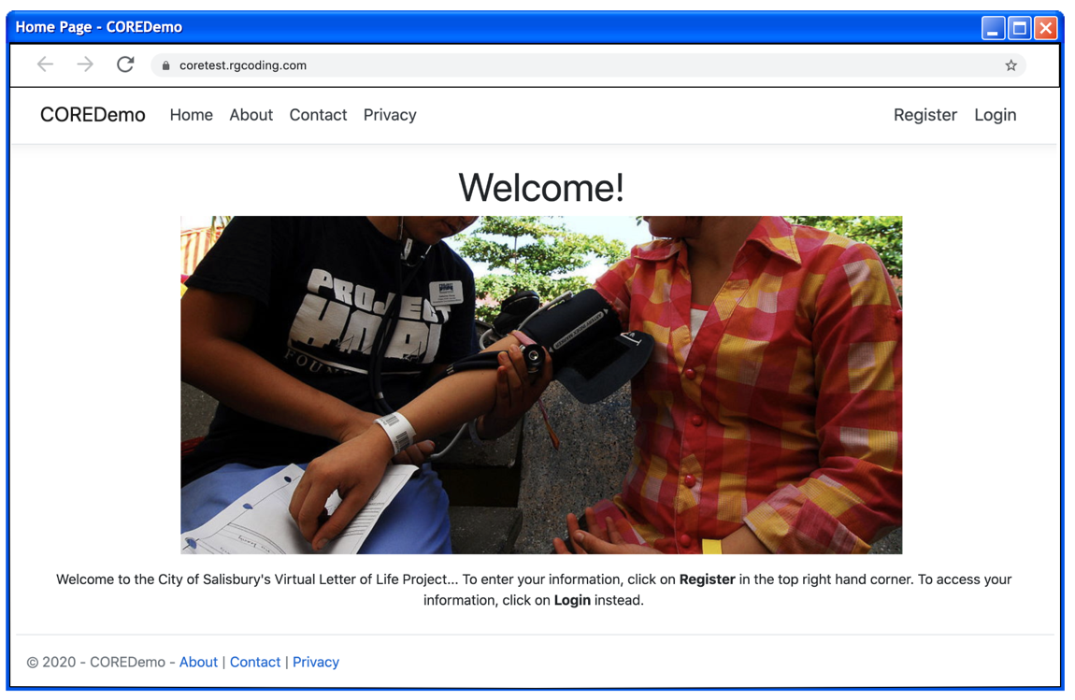

Internal UI functionality:

When it comes to internal functionality, the systems users are populated when users choose to register within the system. The register option is presented here along with the option to sign in.

External UI functionality:

Externally this page presents the user with options to find more information regarding the VLOL system. The options are About, Contact and Privacy.

**2. Register**

Screen Name: VLOL (Virtual Letter of Life) Registration Page

Requirement ID: REQ-1.3

Figure 6. Mockup of VLOL Registration Page.

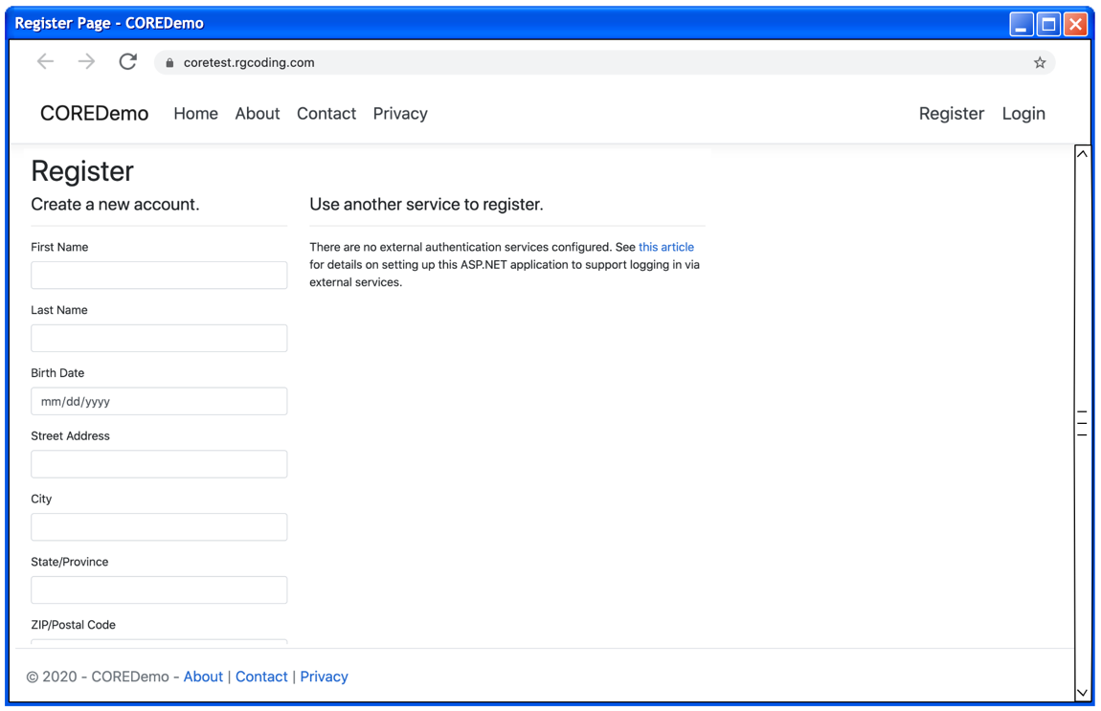

Internal UI functionality:

When it comes to internal functionality, the systems users are populated when users choose to register within the system. Registration collects user data: First Name, Last Name, DOB, Address, City, State, Zip, Phone Number, Email, SSN, Insurance Company, Insurance Policy, Primary Doctor, Primary Doctor Phone, Additional Information, and Password.

External UI functionality:

The registration page functionality effects external users by allowing them to store user credentials into the system. (Username and Password) this is used to allow access to the system.

**3. Login**

Screen Name: VLOL (Virtual Letter of Life) Log In Page

Requirement ID: REQ-1.4, REQ-1.11, REQ-1.18, and REQ-1.26

Figure 7. Mockup of VLOL Login Page.

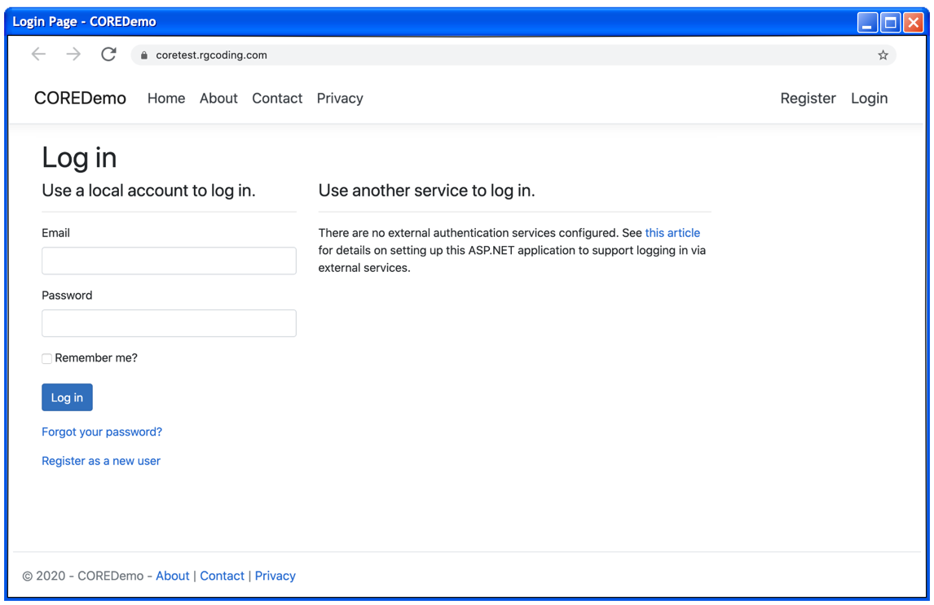

Internal UI functionality:

This login page does not provide any internal functionality.

External UI functionality:

This is the interface that provides system access to external users upon verification of credentials.

**4. About**

Screen Name: VLOL (Virtual Letter of Life) About Page

Requirement ID: REQ-1.1

Figure 8. Mockup of VLOL About Page.

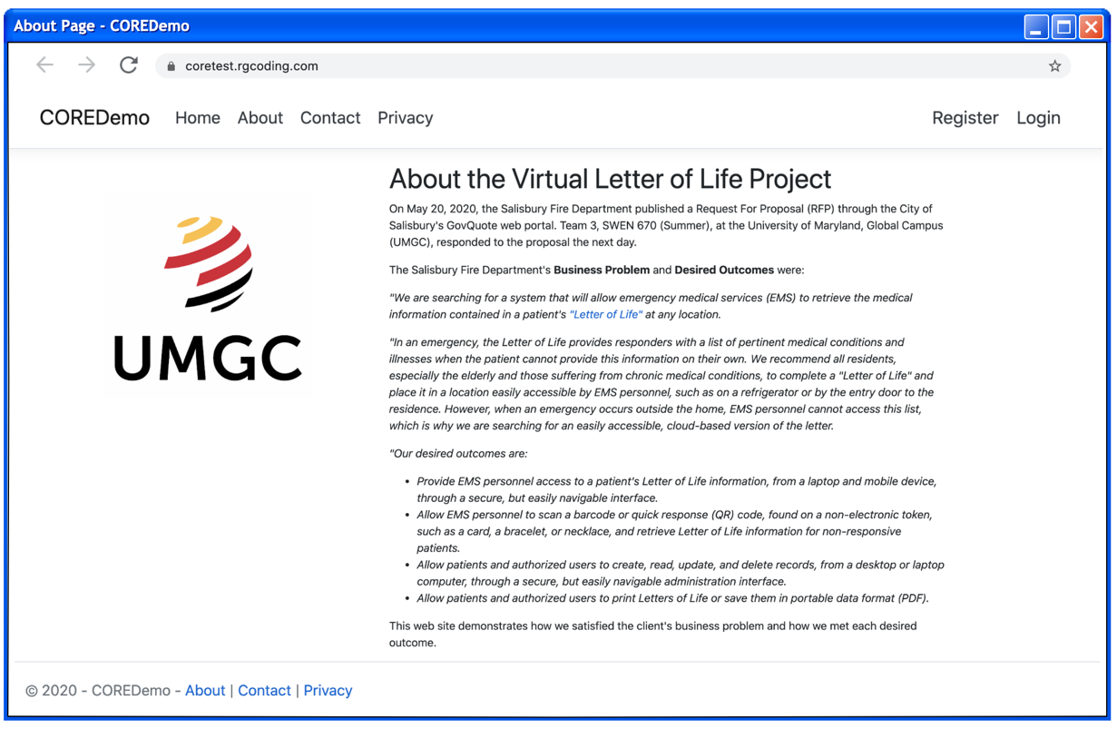

Internal UI functionality:

Internal functionality is not granted to external users from the About Page.

External UI functionality:

The About Page is designed to give users a background of the VLOL system and what it is used for.

**5. Contact**

Screen Name: VLOL (Virtual Letter of Life) Contact Page

Requirement ID: REQ-1.2, REQ-1.10, and REQ-1.17

Figure 9. Mockup of VLOL Contact Page.

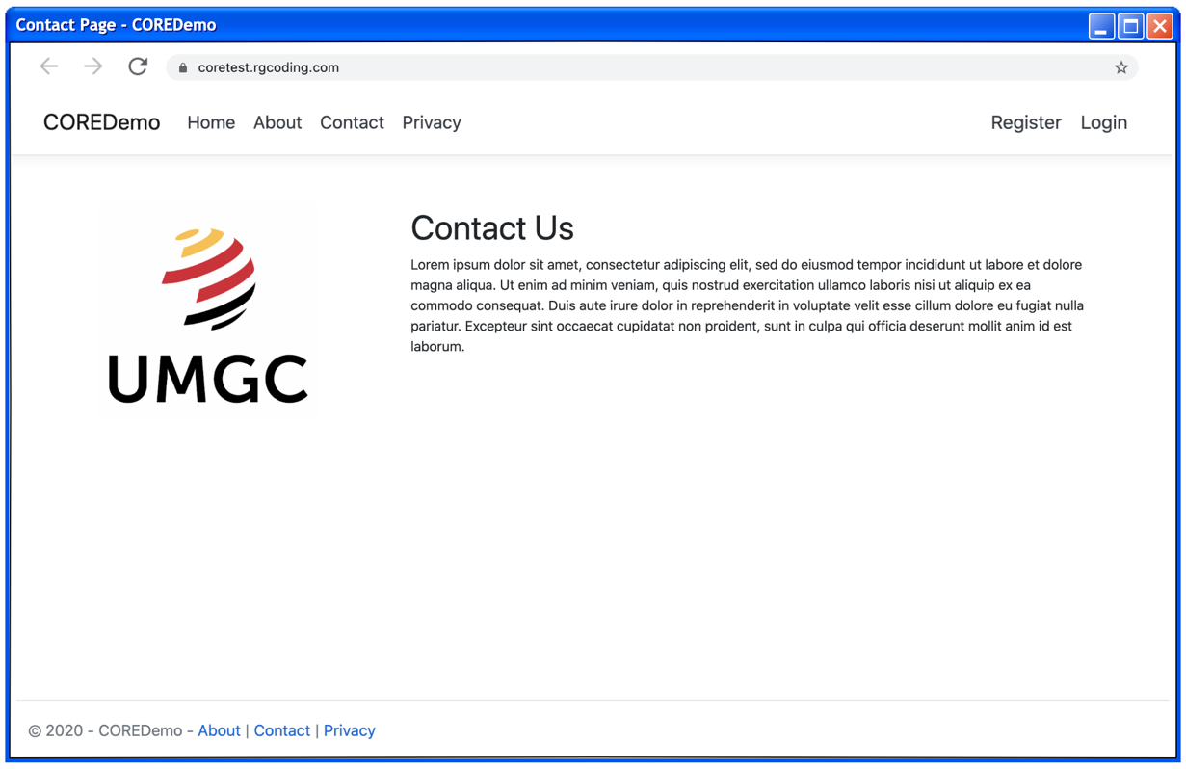

Internal UI functionality:

Internal functionality is not present from the Contact Page.

External UI functionality:

The Contact Page is designed to give users information regarding contacting the Virtual Letter of Life team.

**6.** **Privacy**

Screen Name: VLOL (Virtual Letter of Life) Privacy Page

Requirement ID:

Figure 10. Mockup of VLOL Privacy Policy Page.

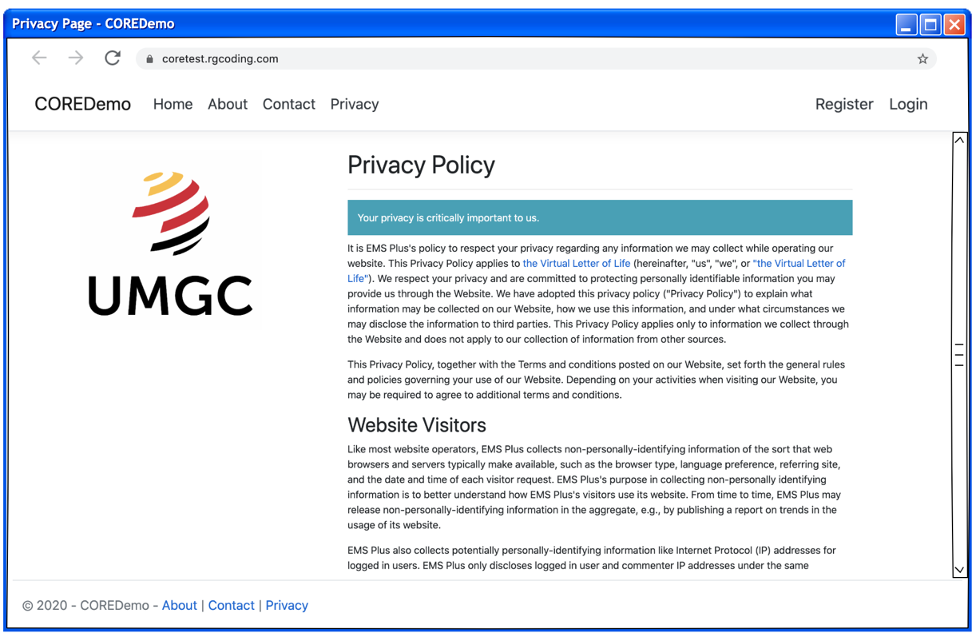

Internal UI functionality:

Internal functionality is not present from the Privacy Page.

External UI functionality:

The Privacy Page is designed to provide users with a guarantee of how their private data is to be handled by the Virtual Letter of Life System.

IV. B. Virtual Letter of Life (Mobile)

**1.** **Home**

Screen Name: VLOL (Virtual Letter of Life) Home Page

Requirement ID: REQ-1.1

Figure 11. Mockup of VLOL Mobile Home Page.

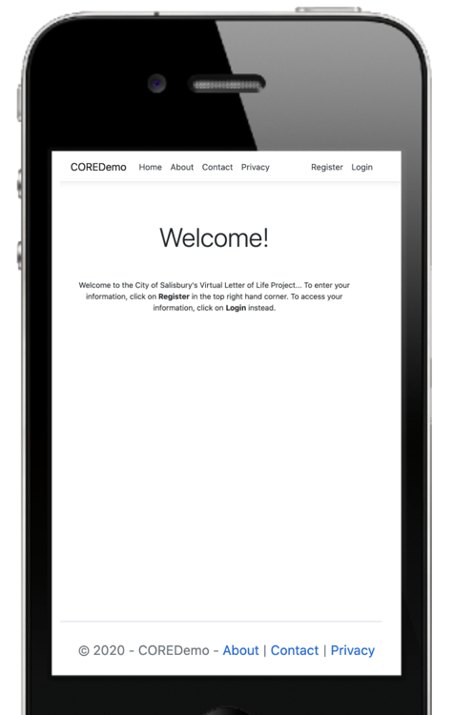

Internal UI functionality:

When it comes to internal functionality, the systems users are populated when users choose to register within the system. The register option is presented here along with the option to sign in.

External UI functionality:

Externally this page presents the user with options to find more information regarding the VLOL system. The options are About, Contact and Privacy.

**2. Register**

Screen Name: VLOL (Virtual Letter of Life) Registration Page

Requirement ID: REQ-1.3

Figure 12. Mockup of VLOL Mobile Registration Page.

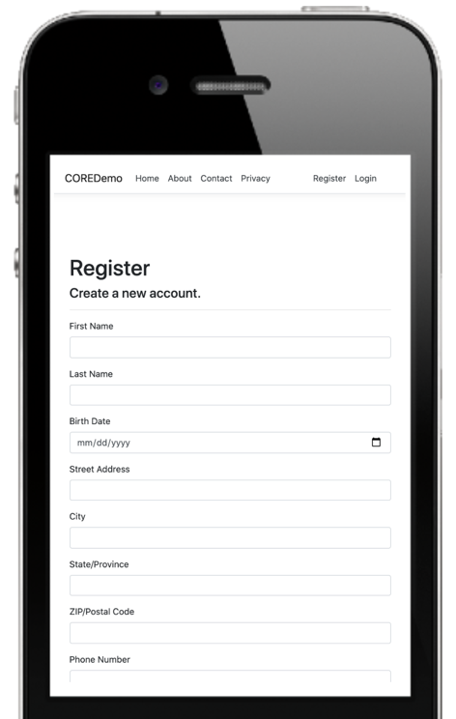

Internal UI functionality:

When it comes to internal functionality, the systems users are populated when users choose to register within the system. Registration collects user data: First Name, Last Name, DOB, Address, City, State, Zip, Phone Number, Email, SSN, Insurance Company, Insurance Policy, Primary Doctor, Primary Doctor Phone, Additional Information, and Password.

External UI functionality:

The registration page functionality effects external users by allowing them to store user credentials into the system. (Username and Password) this is used to allow access to the system.

**3. Login**

Screen Name: VLOL (Virtual Letter of Life) Log In Page

Requirement ID: REQ-1.4, REQ-1.11, REQ-1.18,and REQ-1.26

Figure 13. Mockup of VLOL Mobile Login Page.

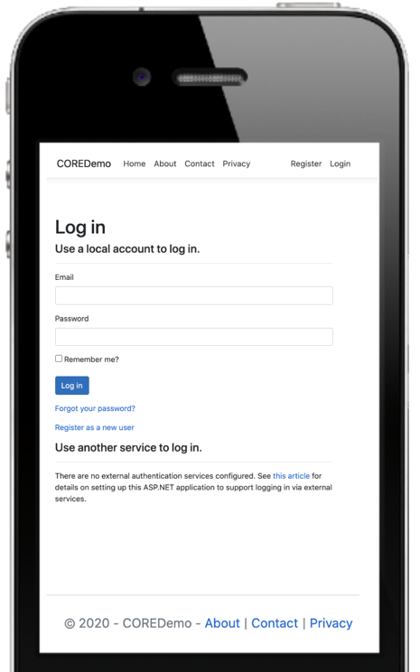

Internal UI functionality:

This login page does not provide any internal functionality.

External UI functionality:

This is the interface that provides system access to external users upon verification of credentials.

**4. About**

Screen Name: VLOL (Virtual Letter of Life) About Page

Requirement ID:

Figure 14. Mockup of VLOL Mobile About Page.

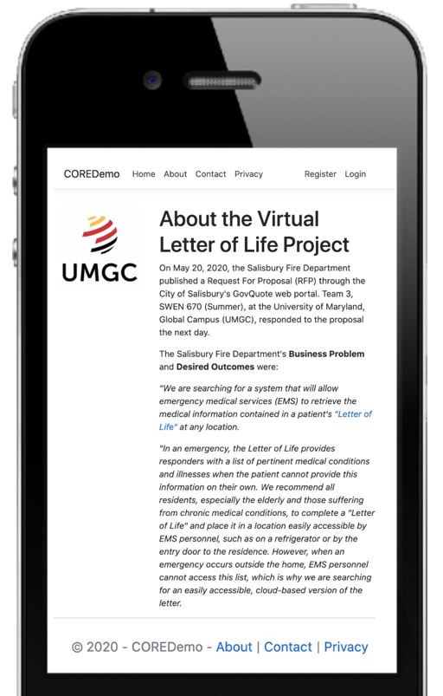

Internal UI functionality:

Internal functionality is not granted to external users from the About Page.

External UI functionality:

The About Page is designed to give users a background of the VLOL system and what it is used for.

**5.** **Contact**

Screen Name: VLOL (Virtual Letter of Life) Contact Page

Requirement ID: REQ-1.2, REQ-1.10,and REQ-1.17

Figure 15. Mockup of VLOL Mobile Contact Page.

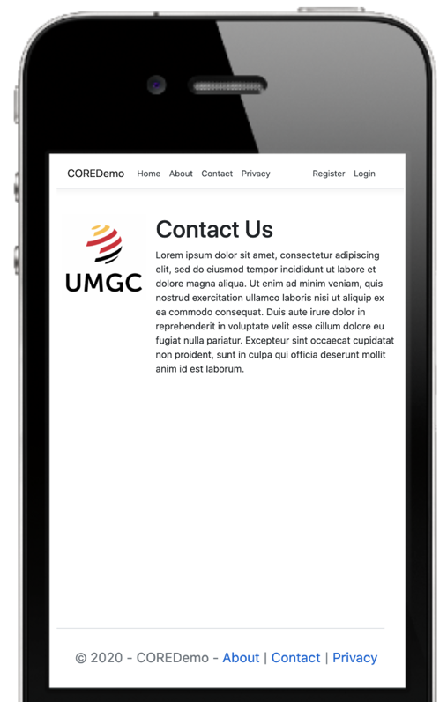

Internal UI functionality:

Internal functionality is not present from the Contact Page.

External UI functionality:

The Contact Page is designed to give users information regarding contacting the Virtual Letter of Life team.

**6.** **Privacy**

Screen Name: VLOL (Virtual Letter of Life) Privacy Page

Requirement ID:

Figure 16. Mockup of VLOL Mobile Privacy Policy Page.

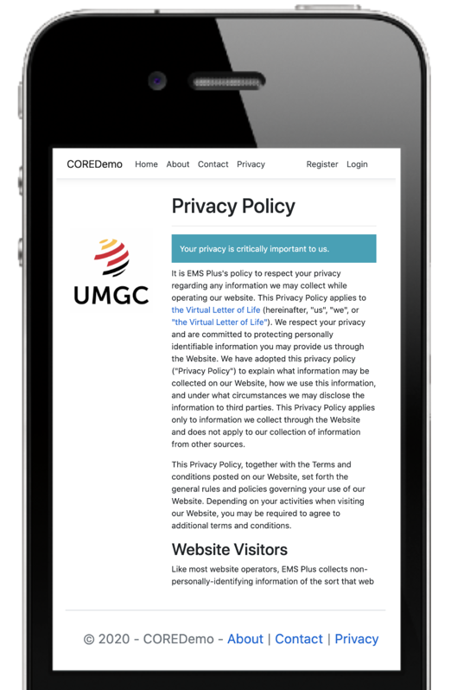

Internal UI functionality:

Internal functionality is not present from the Privacy Page.

External UI functionality:

The Privacy Page is designed to provide users with a guarantee of how their private data is to be handled by the Virtual Letter of Life System.